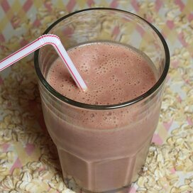

**Sugar-Free PB&J Smoothie**

**Ingredients:**

¾ cup frozen strawberries

¾ cup milk

1 ½ tablespoons peanut butter

1 tablespoon rolled oats

2 teaspoons honey

**Directions:**

1. Blend strawberries, milk, peanut butter, oats, and honey together in a blender until smooth
2. Cook’s Notes – Use any frozen fruit you like in place of the strawberries. I like to use mixed frozen berries

**Nutrition Facts (Per Serving)**

Calories 170 Prep: 5 minutes

Protein 6.9 g (14% DV) Total: 5 minutes

Carbohydrates 19.3 g (6% DV) Servings: 2

Fat 8.3 g (13% DV) Yield: 2 servings

Cholesterol 7.3 mg (2% DV)

Sodium 94.6 mg (4% DV)